Code 1
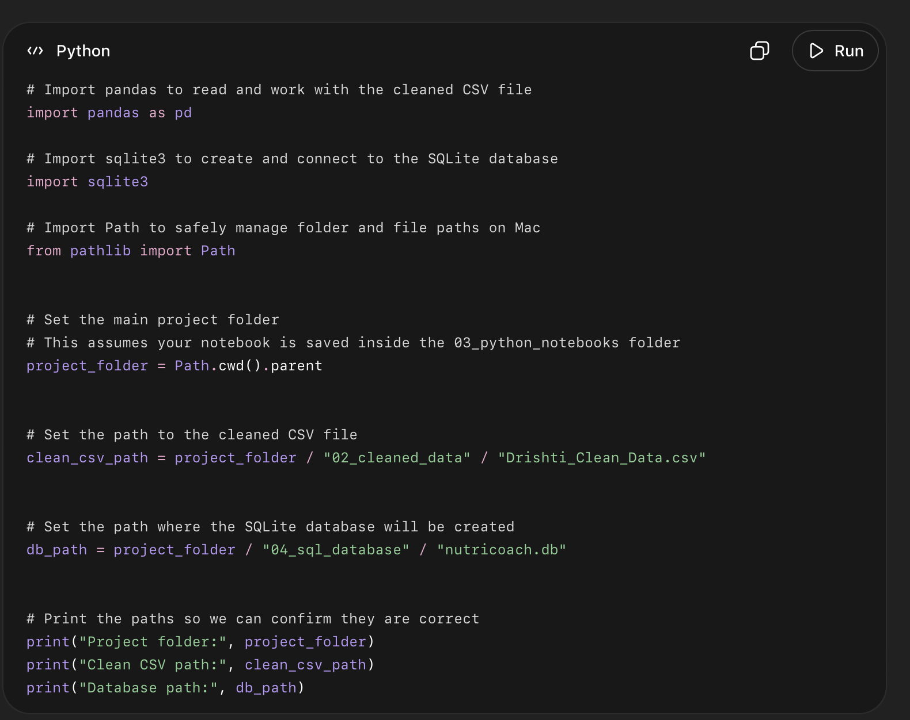

What this code did
- Imported pandas so we can load the cleaned CSV file.
- Imported sqlite3 so we can create the SQLite database.
- Imported Path so file paths work properly on your Mac.
- Set your main project folder location.
- Set the exact location of your cleaned CSV file.
- Set where the SQLite database file will be created.
- Printed the paths so you can check if Jupyter is looking in the correct folders.
Code 2
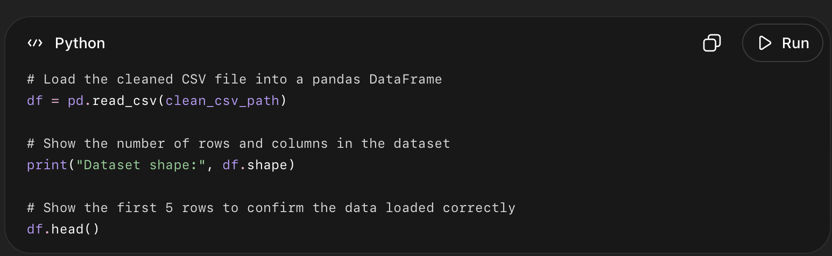

What this code did
- Loaded Drishti_Clean_Data.csv into Python.
- Stored the dataset in a DataFrame named df.
- Printed the dataset shape so we can confirm the row and column count.
- Displayed the first 5 rows so we can visually check that the file loaded correctly.
Code 3
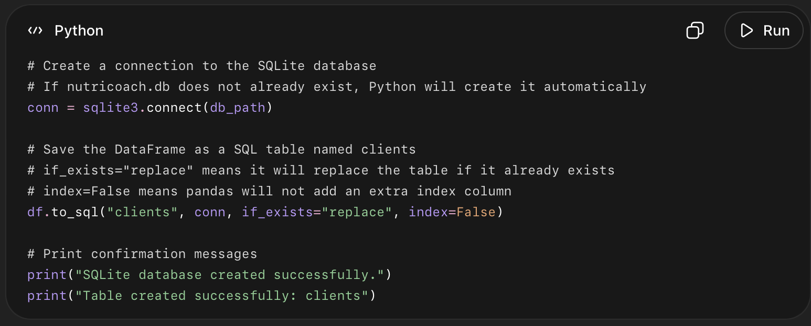

What this code did
- Created a SQLite database file named nutricoach.db.
- Saved it inside your 04_sql_database folder.
- Created a SQL table named clients.
- Loaded all rows and columns from your cleaned DataFrame into the clients table.
- Used if_exists="replace" so if you rerun the code, it refreshes the table instead of duplicating data.
- Used index=False so Python does not create an unnecessary extra column.
Code 4
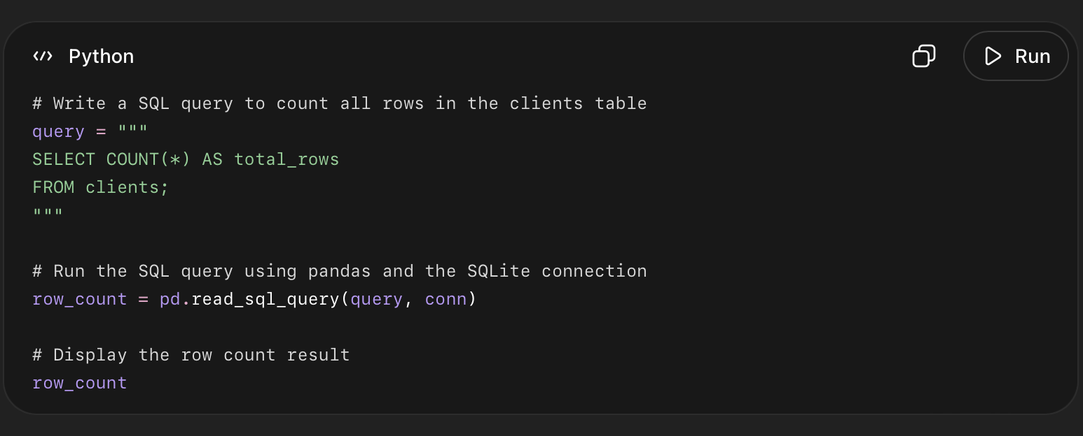

What this code did
- Wrote a SQL query that counts the total number of records in the clients table.
- Used COUNT(*) to count every row.
- Used pd.read_sql_query() to run the SQL query from Python.
- Stored the result in row_count.
- Displayed the result as a small table.

Code 5
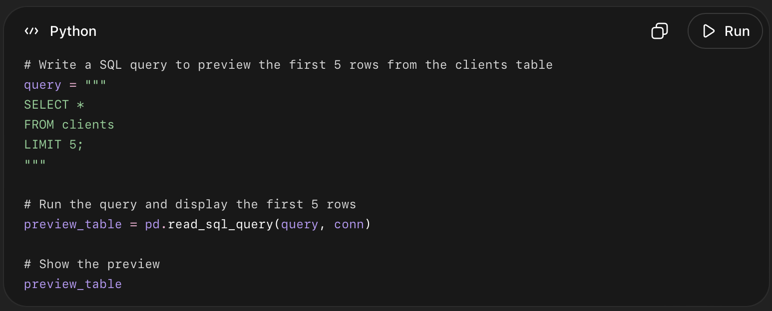

What this code did
- Used SQL to select data from the clients table.
- SELECT * means show all columns.
- FROM clients means the data comes from the clients table.
- LIMIT 5 means only show the first 5 rows.
- This confirms that the actual client records were loaded into SQLite correctly.

Code 6
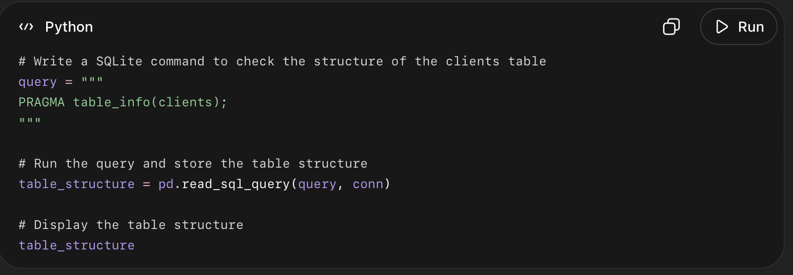

What this code did
- Used PRAGMA table_info(clients) to inspect the structure of the SQL table.
- Showed every column inside the clients table.
- Displayed each column’s name, data type, and position in the table.
- Helped confirm that the cleaned dataset columns were successfully transferred into SQLite.
Code 7
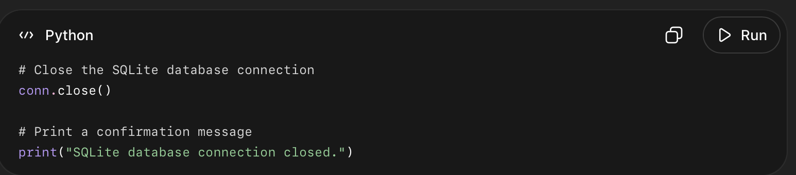

What this code did
- Closed the connection between Python and the SQLite database.
- This is good practice after finishing database setup.
- It makes sure all data is safely saved.
- It prevents the database file from staying locked.

